4.1.1 Literacy Status of Migrants
Literacy is one of the most important social characteristics of a population, as it has a direct bearing on employment opportunities, awareness, and the overall capacity of individuals to adapt to a new social and economic environment after migration. In this study, an attempt has been made to examine the literacy status of the migrant population of Shankharapur Ward 9 (Sankhu), considering the population aged 5 years and above. Based on the responses obtained through the questionnaire survey, the distribution of the migrant population by literacy status and sex is presented in the table below.
Table No. 4.1.1: Distribution of Migrants by Literacy Status and Sex (Population Aged 5 Years and Above)
Literacy Status | Male No. | Male % | Female No. | Female % | Total No. | Total %
Literate | 164 | 93.7 | 107 | 66.9 | 271 | 80.9
Illiterate | 11 | 6.3 | 53 | 33.1 | 64 | 19.1
Total | 175 | 100.0 | 160 | 100.0 | 335 | 100.0
Source: Field Survey, 2025.
Table No. 4.1.1 shows that, among the migrant population aged 5 years and above, 271 persons (80.9%) are literate while 64 persons (19.1%) are illiterate. Literacy is markedly higher among males, at 93.7 percent, compared with 66.9 percent among females, and correspondingly the illiteracy rate among females (33.1%) is more than five times that among males (6.3%). This gender gap in literacy is consistent with the wider Nepalese pattern in which older-generation women have historically had less access to formal schooling than men, and it suggests that female migrants in the study area may face relatively greater constraints in accessing information, services and employment opportunities at the destination than their male counterparts.
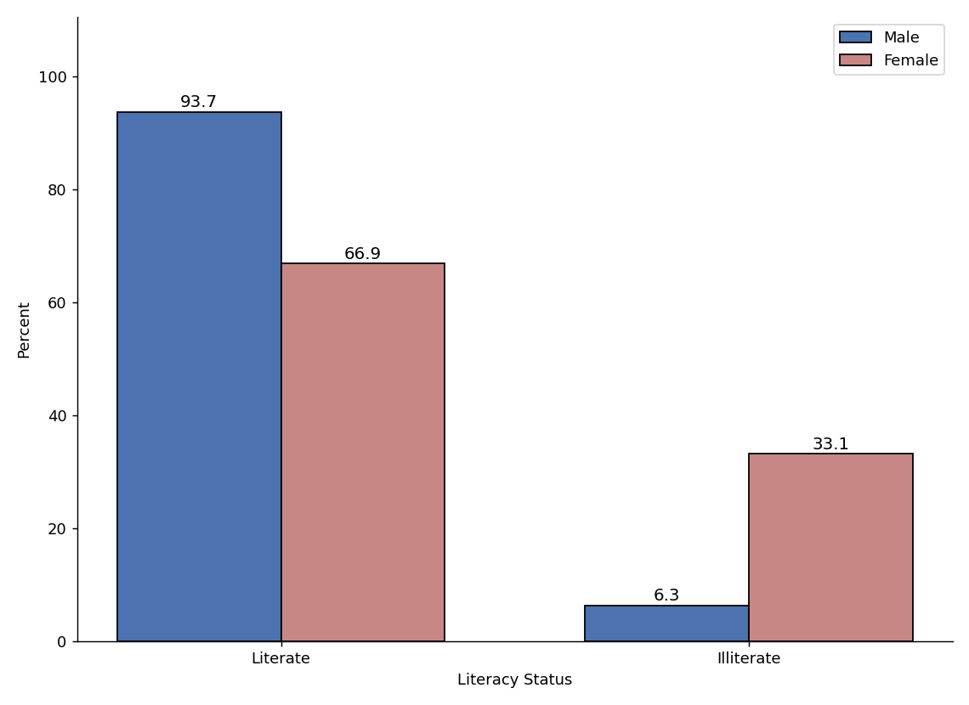
Figure No. 1: Distribution of Migrants by Literacy Status and Sex

4.1.2 Ethnicity
Nepal is a multi-cultural, multi-ethnic and multi-religious country, home to a wide variety of ethnic groups, each with their own distinct customs and traditions. In this context, it is worth investigating whether certain ethnic groups have been more involved in migration than others. Based on the responses obtained through the questionnaire survey, the distribution of migrant households by ethnicity is presented in the table below.
Table No. 4.1.2: Distribution of Migrant Households by Ethnicity
Ethnicity | No. of Households | Percent (%)
Brahmin | 28 | 31.5
Chhetri | 32 | 36.0
Janajati | 23 | 25.8
Dalit | 6 | 6.7
Total | 89 | 100.0
Source: Field Survey, 2025.
Table No. 4.1.2 shows that out of 89 migrant households, Chhetri households are in highest number with 36.0 percent, followed by Brahmin with 31.5 percent. Janajati households cover 25.8 percent and Dalit households are lowest with only 6.7 percent. This shows that Brahmin and Chhetri together make more than two third (67.5%) of the total migrant households in the study area, while Dalit households have migrated in a much smaller number. This suggests that migration in the study area is not evenly distributed across ethnic groups, with Brahmin and Chhetri households showing a notably higher propensity to migrate than Dalit households.
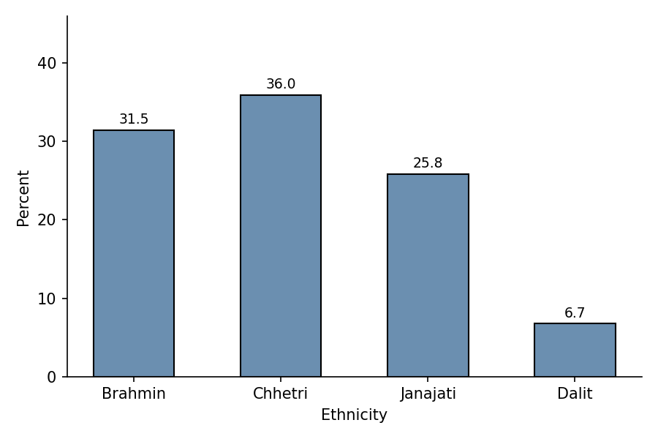
Figure No. 2: Distribution of Migrant Households by Ethnicity

4.1.3 Religion
Nepal was declared a secular state by the reinstated parliament in 2006, a status subsequently upheld by the Interim Constitution of 2007 and retained in the Constitution of Nepal, 2015. This declaration reflects the state's formal commitment to treat and respect all religions practiced by the Nepalese people equally. However, the Hindu religion has traditionally remained the majority religion of the country, followed by Buddhist, Muslim, Kirat and Christian populations, among others; the National Population Census 2021 recorded 81.19 percent of the population as Hindu, 8.21 percent as Buddhist, 5.09 percent as Muslim, 3.17 percent as Kirat and 1.76 percent as Christian (National Statistics Office [NSO], 2021). In this study, an attempt has also been made to examine whether there is any relationship between the religion of the migrants and the process of in-migration in the study area. Based on the responses obtained through the questionnaire survey, the distribution of migrant households by religion is presented in the table below.
Table No. 4.1.3: Distribution of Migrant Households by Religion
Religion | No. of Households | Percent (%)
Hindu | 60 | 67.4
Buddhist | 23 | 25.8
Muslim | 0 | 0.0
Christian | 6 | 6.7
Total | 89 | 100.0
Source: Field Survey, 2025.
Table No. 4.1.3 shows that out of 89 migrant households, Hindu households form the large majority with 67.4 percent, followed by Buddhist households with 25.8 percent and Christian households with 6.7 percent. No Muslim household was recorded among the migrant households in the study area. While Hindu households remain the majority among migrants, consistent with their national majority status, their share among the migrants (67.4%) is notably lower than their share nationally (81.19%, NSO, 2021), while Buddhist households appear over-represented (25.8% against a national 8.21%). As these figures cover the complete population of migrant households in the study area rather than a sample drawn from it, this gap reflects an actual difference in religious composition between the study area and the national population, rather than a limitation of sampling.
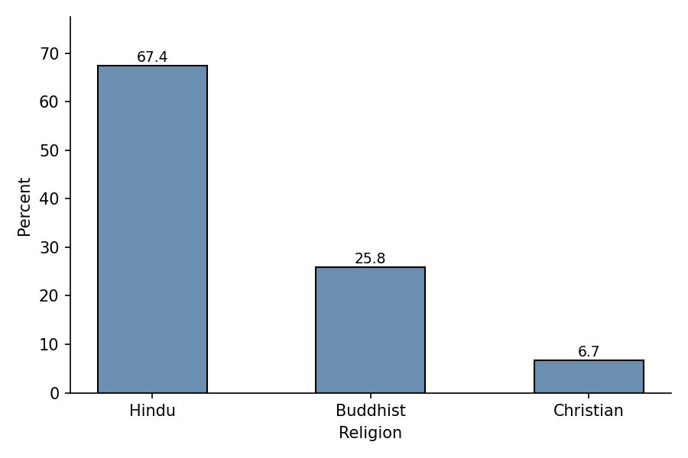
Figure No. 3: Distribution of Migrant Households by Religion

4.1.4 Size of Land Holding
Land ownership is one of the key indicators of the economic status of a household, and it is also directly relevant to how migrant status is recognized in the study area. During the course of this study, an inquiry was made with the administrative body of the municipality regarding the criteria used to grant migrant status to in-migrating households. It was learnt that a change in provision was introduced in 2076 B.S. [year to be confirmed], under which a migrant household is required to hold some land in its own name within the municipality in order to be granted migrant status. Prior to this provision, households without any land ownership were also able to obtain a migration certificate. In view of this administrative context, this study examines not only the broader division between land-owning and non-land-owning migrant households, but also the variation in the size of land holding among the households that do own land.
Table No. 4.1.4: Distribution of Migrant Households by Size of Land Holding
Size of Land Holding | No. of Households | Percent (%)
Ropani | 16 | 18.0
Aana | 62 | 69.7
Paisa | 0 | 0.0
Daam | 0 | 0.0
Others | 11 | 12.4
Total | 89 | 100.0
Source: Field Survey, 2025.
Table No. 4.1.4 shows that all 89 migrant households in the study area reported owning some land, with no household falling into a landless category. This is consistent with the administrative provision noted above, under which land ownership has become a precondition for obtaining migrant status in the municipality. Among the land-owning households, however, there is considerable variation in the size of holding. The majority of households, 69.7 percent, own land measured in Aana, a comparatively small unit of land measurement, while 18.0 percent hold larger parcels measured in Ropani. The remaining 12.4 percent hold land under other or mixed measurement categories. This indicates that while land ownership is now near-universal among migrant households, the actual size of land held by most of these households remains modest.
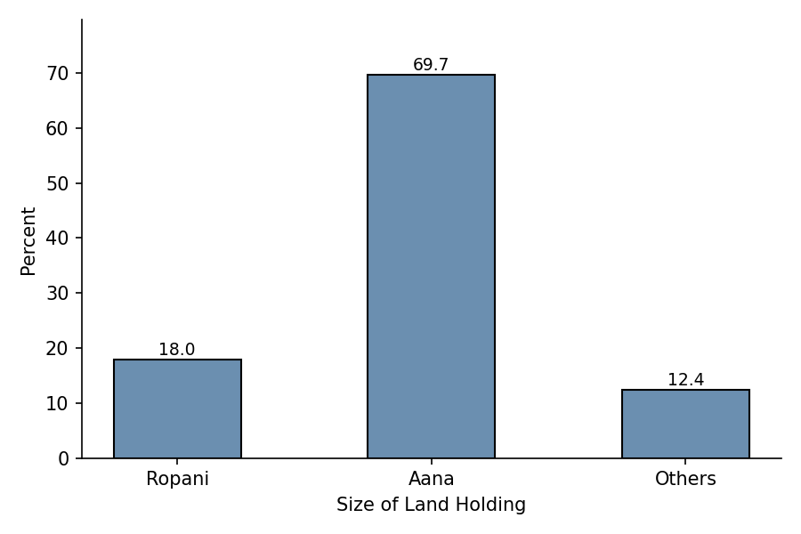
Figure No. 4: Distribution of Migrant Households by Size of Land Holding

4.1.5 Source of Drinking Water
Access to a reliable source of drinking water is a basic necessity and is often regarded as one of the physical facilities that influences a household's decision on where to settle. Water, as such, is not a scarce resource in the study area, as there are multiple water source points (locally known as muhan) from which water is distributed to households, serving both local and migrant populations alike. Drinking water itself is available in adequate quantity to meet household needs. However, for those requiring a greater quantity of water, such as for house construction or irrigation, a considerable number of households opt for boring (tube-well) to fulfil this additional demand. Based on the responses obtained through the questionnaire survey, the distribution of migrant households by their main source of drinking water is presented in the table below.
Table No. 4.1.5: Distribution of Migrant Households by Source of Drinking Water
Source of Water | No. of Households | Percent (%)
Piped | 48 | 53.9
Boring | 35 | 39.3
Well | 6 | 6.7
Total | 89 | 100.0
Source: Field Survey, 2025.
Table No. 4.1.5 shows that more than half of the migrant households, 53.9 percent, rely on piped water as their main source of drinking water, while 39.3 percent depend on boring (tube-well) and 6.7 percent depend on well water. All 89 migrant households reported access to at least one of these sources, confirming that water is not a scarce resource for migrant households in the study area. The considerable share relying on boring (39.3%) is consistent with the pattern noted above, whereby households use boring primarily to meet additional water requirements such as construction and irrigation, rather than because piped drinking water is unavailable to them.
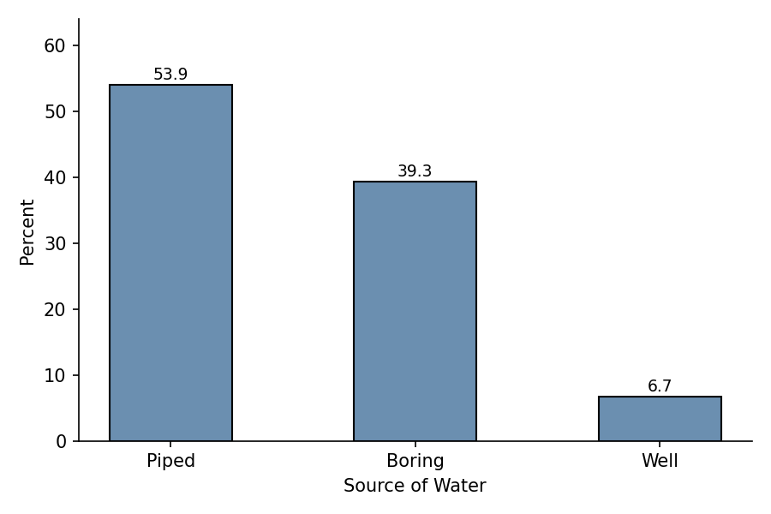
Figure No. 5: Distribution of Migrant Households by Source of Drinking Water

4.2 Demographic Characteristics

4.2.1 Age and Sex Composition of Migrants
Age and sex composition is one of the most important demographic parameters, as it has a direct bearing on the volume, direction and pattern of migration. It also provides a basis for assessing the potential workforce and dependency burden of the migrant population. Based on the responses obtained through the questionnaire survey, the distribution of the migrant population by five-year age group and sex is presented in the table below.
Table No. 4.2.1: Distribution of Migrant Population by Five-Year Age Group and Sex
Age Group | Male No. | Male % | Female No. | Female % | Total No. | Total %
0-4 | 6 | 3.3 | 4 | 2.4 | 10 | 2.9
5-9 | 7 | 3.9 | 4 | 2.4 | 11 | 3.2
10-14 | 14 | 7.7 | 11 | 6.7 | 25 | 7.2
15-19 | 7 | 3.9 | 10 | 6.1 | 17 | 4.9
20-24 | 20 | 11.0 | 13 | 7.9 | 33 | 9.6
25-29 | 15 | 8.3 | 15 | 9.1 | 30 | 8.7
30-34 | 19 | 10.5 | 17 | 10.4 | 36 | 10.4
35-39 | 12 | 6.6 | 17 | 10.4 | 29 | 8.4
40-44 | 12 | 6.6 | 21 | 12.8 | 33 | 9.6
45-49 | 19 | 10.5 | 8 | 4.9 | 27 | 7.8
50-54 | 12 | 6.6 | 18 | 11.0 | 30 | 8.7
55-59 | 16 | 8.8 | 12 | 7.3 | 28 | 8.1
60-64 | 10 | 5.5 | 3 | 1.8 | 13 | 3.8
65+ | 12 | 6.6 | 11 | 6.7 | 23 | 6.7
Total | 181 | 100.0 | 164 | 100.0 | 345 | 100.0
Source: Field Survey, 2025.
Table No. 4.2.1 shows that the migrant population of the study area consists of 345 persons, of whom 181 (52.5%) are male and 164 (47.5%) are female, giving a sex ratio of approximately 110 males per 100 females. The largest concentration of the migrant population falls in the age group 30-34 years (10.4%), followed by the 20-24 and 40-44 age groups, each accounting for 9.6 percent. Taken together, the economically active age groups between 20 and 49 years account for close to half of the total migrant population, which suggests that migration into the study area is dominated by persons of working age, consistent with employment and livelihood-related motives. Among children below 15 years, the 10-14 age group is comparatively large (7.2%), while the population aged 65 years and above constitutes 6.7 percent of the total, indicating a relatively modest elderly dependent population among migrants.
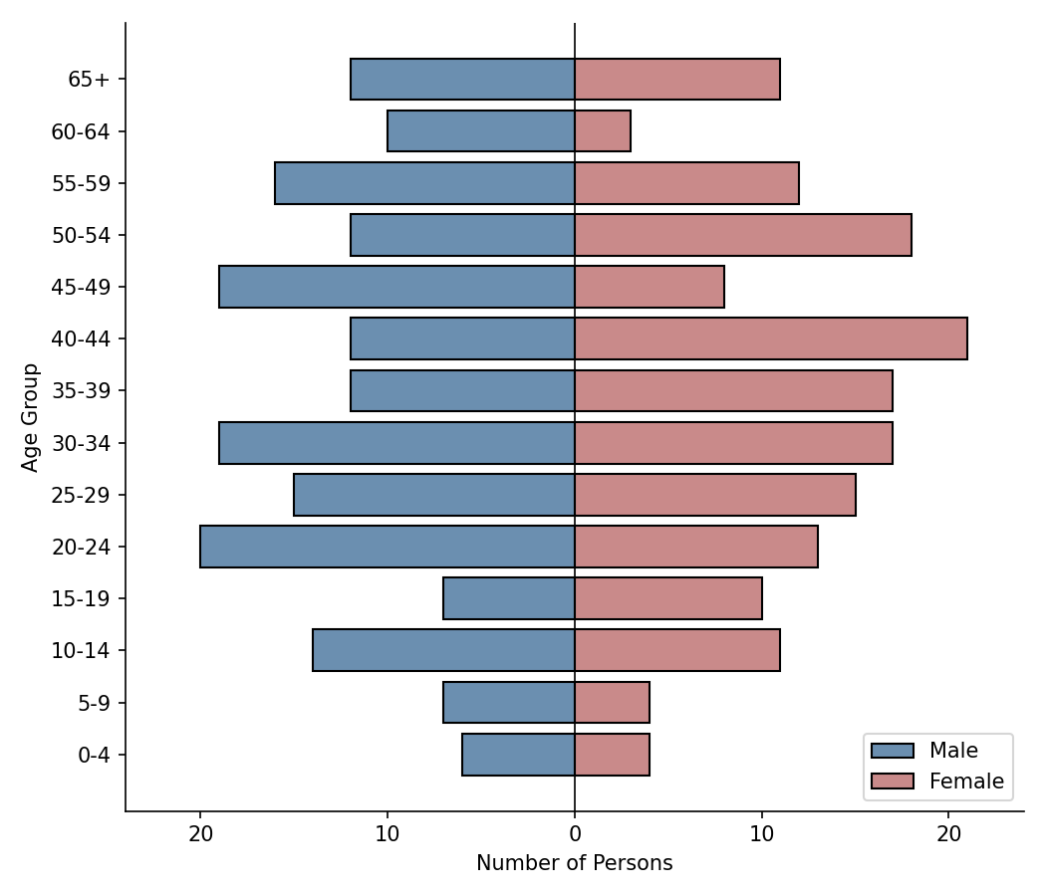
Figure No. 6: Age-Sex Pyramid of the Migrant Population

4.2.2 Marital Status of Migrants
Marital status is an important demographic attribute that has a bearing on household formation, family responsibilities, and the decision-making process underlying migration. Information on the marital status of migrants by sex, obtained from the questionnaire survey, is presented in the table below.
Table No. 4.2.2: Distribution of Migrants by Marital Status and Sex
Marital Status | Male No. | Male % | Female No. | Female % | Total No. | Total %
Unmarried | 69 | 41.1 | 54 | 34.6 | 123 | 38.0
Married | 99 | 58.9 | 102 | 65.4 | 201 | 62.0
Total | 168 | 100.0 | 156 | 100.0 | 324 | 100.0
Source: Field Survey, 2025.
Table No. 4.2.2 shows that among the migrants covered under this question, 201 (62.0%) are married and 123 (38.0%) are unmarried. The proportion married is higher among females (65.4%) than among males (58.9%), while the reverse holds for the unmarried category, where males (41.1%) outnumber females (34.6%) in proportional terms. This pattern suggests that a considerable share of migration into the study area involves married individuals, which is consistent with family-related and livelihood-related motives for migration rather than migration of unattached individuals alone. It may be noted that the total number of migrants reported under marital status (324) is lower than the total migrant population of 345 shown in Table No. 4.2.1. This is because the marital status question was administered only to migrants aged 10 years and above; excluding the 0-4 and 5-9 age groups (21 children, comprising 13 males and 8 females) from Table No. 4.2.1 reduces the population to exactly 168 males and 156 females, matching Table No. 4.2.2.
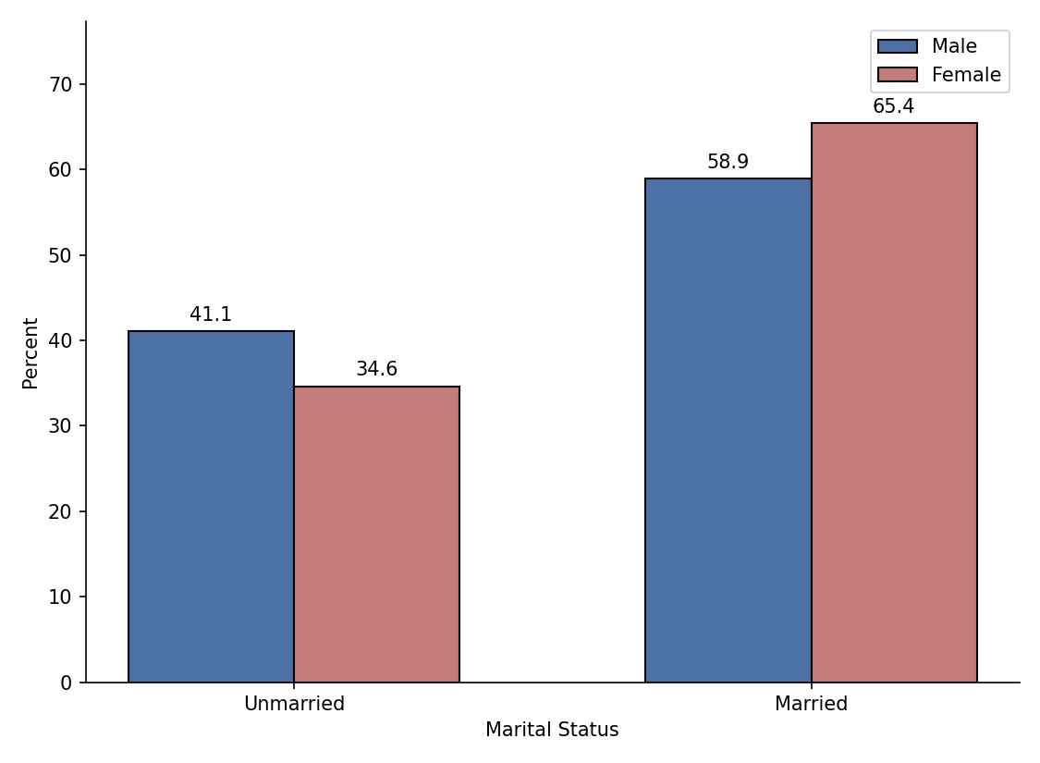
Figure No. 7: Marital Status of Migrants by Sex

4.2.3 Family Size
Family size is closely linked to household resource pressure and is often considered one of the underlying factors behind the decision to migrate. Larger families face greater demand on limited land, income, and housing space, which can act as a push factor for out-migration from the place of origin. Information on the family size of the migrant households surveyed is presented below.
Table No. 4.2.3: Distribution of Migrant Households by Family Size
Family Size | No. of Households | Percent
Below 5 | 69 | 77.5
5-6 | 15 | 16.9
Above 6 | 5 | 5.6
Total | 89 | 100.0
Source: Field Survey, 2025.
Table No. 4.2.3 shows that the majority of migrant households, 69 (77.5%), have a family size below 5 members. Households with 5 to 6 members account for 15 (16.9%), while only 5 households (5.6%) have more than 6 members. Taking the total number of migrant household members (345) and dividing it by the total number of migrant households (89) gives an average family size of 345 ÷ 89 = 3.88 persons per household. This predominance of small households is consistent with Nepal's broader demographic trend: the national average household size fell from 4.88 persons in 2011 to 4.37 persons in 2021 (NSO, 2021), and Bagmati Province, where the study area is located, recorded an even lower average of 3.89 persons per household, among the lowest of any province in the country. The small size of migrant households in the study area therefore mirrors both the national shift toward nuclear family structures — nuclear households (6,660,481) vastly outnumber joint households (6,096) in the 2021 census — and the specifically urban character of Shankharapur Ward 9 (Sankhu), as migrants typically relocate with only their immediate family members rather than the full extended household.
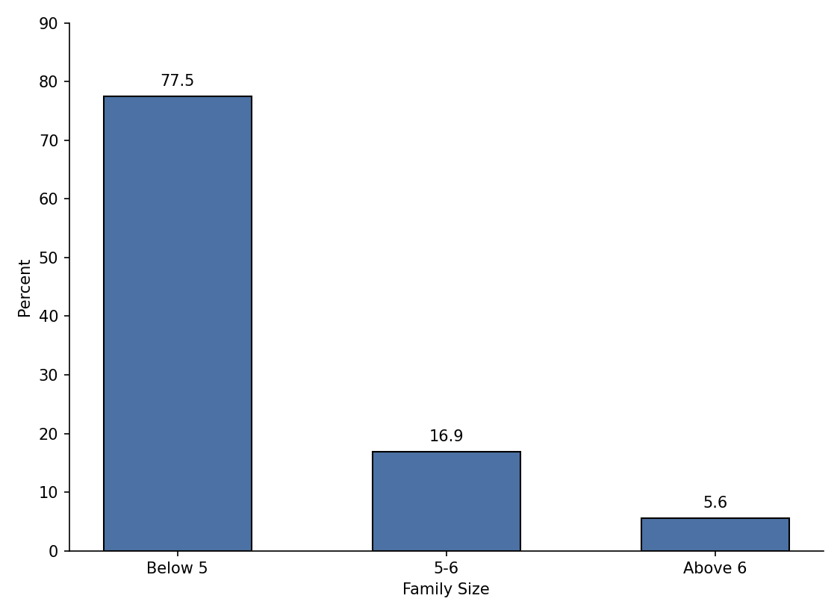
Figure No. 8: Distribution of Migrant Households by Family Size

4.2.4 Age Dependency Ratio
The age dependency ratio measures the economic burden that the population outside the working age places on the population within the working age group. For this purpose, the population is divided into three broad age categories: children aged 0-14 years, the working-age population aged 15-64 years, and the elderly population aged 65 years and above. The child and the elderly population together are treated as the economically dependent population, while the population aged 15-64 years is treated as the economically active population. The child dependency ratio, the old age dependency ratio and the total dependency ratio are calculated as follows:
In the context of a migration study, the age dependency ratio also serves as a useful indirect indicator of the underlying motive of migration, in addition to measuring the economic burden on the working-age population. A relatively low dependency ratio generally suggests that migration is driven primarily by working-age individuals in search of better earning opportunities, since such migrants are less likely to bring dependent children or elderly members along with them. A comparatively higher dependency ratio, on the other hand, may point toward motives other than employment alone: a high old age dependency ratio could reflect migration undertaken for access to better medical facilities or a wish to remain close to relatives in old age, while a high child dependency ratio could reflect migration undertaken to provide children with a better environment in which to grow up. This interpretation is used here as an indicative rather than definitive link, and is examined further in Chapter Five in light of the reasons for migration reported directly by the respondents.
Child Dependency Ratio = (Population aged 0-14 years ÷ Population aged 15-64 years) × 100
Old Age Dependency Ratio = (Population aged 65 years and above ÷ Population aged 15-64 years) × 100
Total Dependency Ratio = Child Dependency Ratio + Old Age Dependency Ratio
Based on the age-sex distribution of the migrant population presented in Table No. 4.2.1, the age dependency ratio of the study area by sex is calculated and presented in the table below.
Table No. 4.2.4: Age Dependency Ratio of the Migrant Population by Sex
Age Dependency Ratio | Male | Female | Total
Child Dependency Ratio | 19.0 | 14.2 | 16.7
Old Age Dependency Ratio | 8.5 | 8.2 | 8.3
Total Dependency Ratio | 27.5 | 22.4 | 25.0
Source: Field Survey, 2025.
Table No. 4.2.4 shows that the overall age dependency ratio of the migrant population is 25.0, meaning that for every 100 persons of working age (15-64 years), there are 25 dependents to support, comprising 16.7 child dependents and 8.3 elderly dependents. The dependency burden is somewhat higher among males (27.5) than among females (22.4), and this difference is driven almost entirely by the child dependency ratio, which stands at 19.0 for males against 14.2 for females, while the old age dependency ratio is nearly identical between the two sexes (8.5 for males and 8.2 for females). The comparatively low overall dependency ratio, well below the level typically associated with a broad-based, high-fertility population, is consistent with the earlier finding that the migrant population is concentrated in the economically active age groups (Table No. 4.2.1), reinforcing the view that migration into the study area is predominantly driven by working-age individuals and their immediate families rather than by dependents alone.
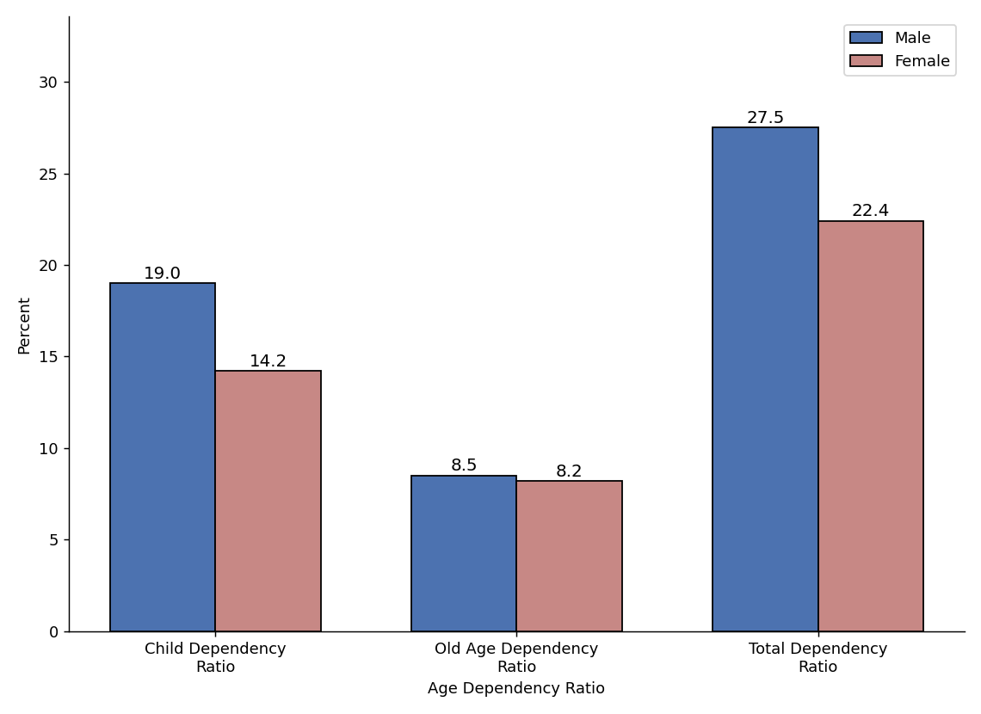
Figure No. 9: Age Dependency Ratio of the Migrant Population by Sex

5.1 Causes of Migration
The causes of migration refer to the various factors that motivate people to leave one place and settle in another. These factors are broadly understood in terms of push and pull factors: push factors are the unfavourable conditions at the place of origin that compel people to move away, while pull factors are the favourable conditions at the place of destination that draw people towards it. This section examines the causes associated with in-migration into Shankharapur Ward 9 (Sankhu), beginning with the reasons that led migrant households to leave their place of origin.

5.1.1 Reasons for Leaving the Place of Origin
The reason for leaving the place of origin reflects the push factors that influenced migrant households to move away from their previous place of residence. In this study, respondents were asked to identify the single most important reason that led them to leave their place of origin. Based on the responses obtained through the questionnaire survey, the distribution of migrant households by reason for leaving the place of origin is presented in the table below.
Table No. 5.1.1: Distribution of Migrant Households by Reason for Leaving Place of Origin
Reason for Leaving | No. of Households | Percent (%)
Limited infrastructure | 31 | 34.8
Limited job opportunity | 24 | 27.0
Limited market | 18 | 20.2
Limited arable land | 7 | 7.9
Government job | 5 | 5.6
Victim of conflict | 4 | 4.5
Total | 89 | 100.0
Source: Field Survey, 2025.
Table No. 5.1.1 shows that limited infrastructure is the single most commonly reported reason for leaving the place of origin, cited by 31 households (34.8%), followed by limited job opportunity (24 households, 27.0%) and limited market (18 households, 20.2%). Taken together, these three reasons — infrastructure, employment and market access — account for more than four-fifths (82.0%) of all households, indicating that the decision to leave the place of origin in this study area is overwhelmingly linked to the underdevelopment of physical and economic infrastructure rather than to social or political causes. Limited arable land was reported by 7 households (7.9%), reflecting land scarcity or fragmentation as a comparatively minor push factor. Only 5 households (5.6%) left their place of origin owing to a government job posting, and just 4 households (4.5%) reported having been displaced as victims of conflict, suggesting that career-related transfers and conflict-induced displacement played only a marginal role in shaping the in-migration stream into this study area.
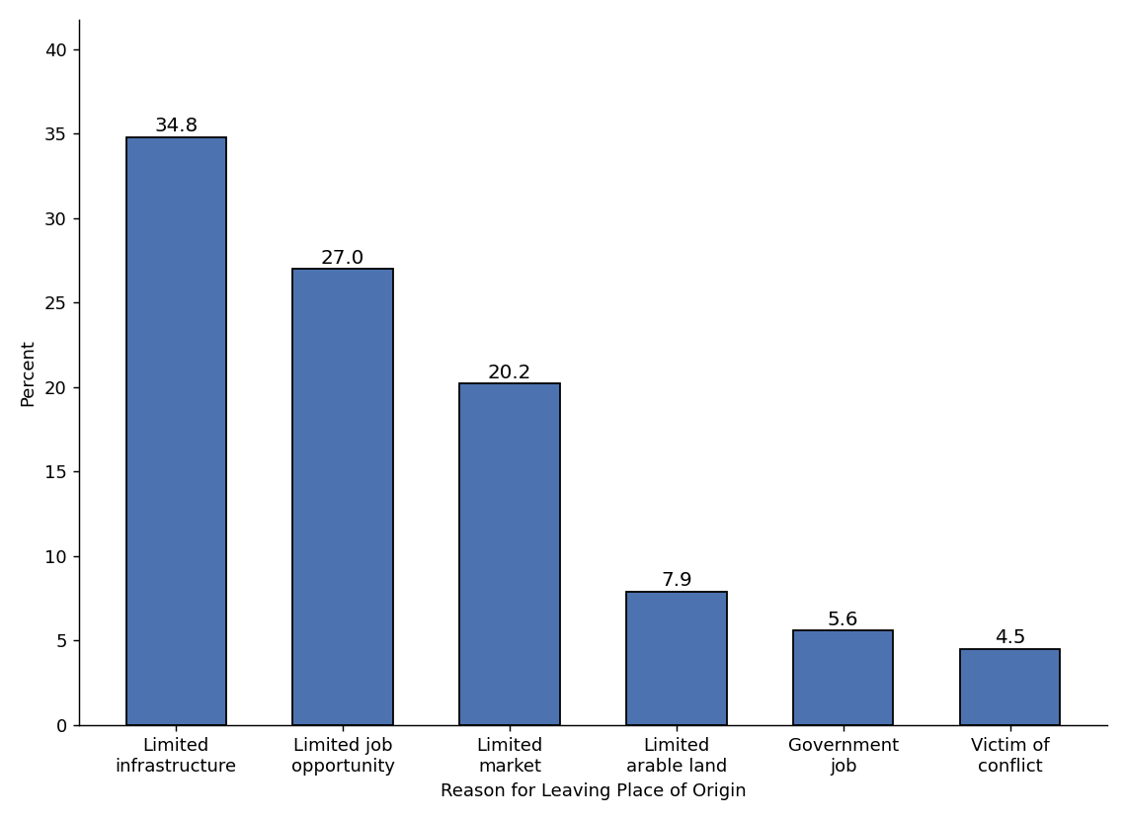
Figure No. 10: Distribution of Migrant Households by Reason for Leaving Place of Origin

5.1.2 Place of Origin
The place of origin indicates the geographic distance and administrative boundary that migrant households crossed before settling in Shankharapur Ward 9 (Sankhu). It is an important indicator of the scale of movement, since a household relocating from within the same local unit faces a very different set of push and pull factors than one arriving from a distant district. Based on the responses obtained through the questionnaire survey, the distribution of migrant households by their place of origin before migration is presented in the table below.
Table No. 5.1.2: Distribution of Migrant Households by Place of Origin
Place of Origin | No. of Households | Percent (%)
Same palika | 5 | 5.6
Other palika of same district | 19 | 21.3
Other district | 65 | 73.0
Total | 89 | 100.0
Source: Field Survey, 2025.
Table No. 5.1.2 shows that the overwhelming majority of migrant households, 65 out of 89 (73.0%), moved into Shankharapur Ward 9 (Sankhu) from a different district altogether, indicating that long-distance, inter-district migration is by far the dominant pattern of in-migration in the study area. A further 19 households (21.3%) migrated from another palika within the same district, representing a shorter, intra-district move. Only 5 households (5.6%) originated from within the same palika, suggesting that migration confined to the same local unit is comparatively rare. This pattern is consistent with the findings in Section 5.1.1, where limited infrastructure, job opportunity and market access at the place of origin were reported as the leading reasons for leaving: households facing such constraints appear willing to cross considerable administrative distance, well beyond their own district, to reach the physical and economic facilities available in Sankhu.
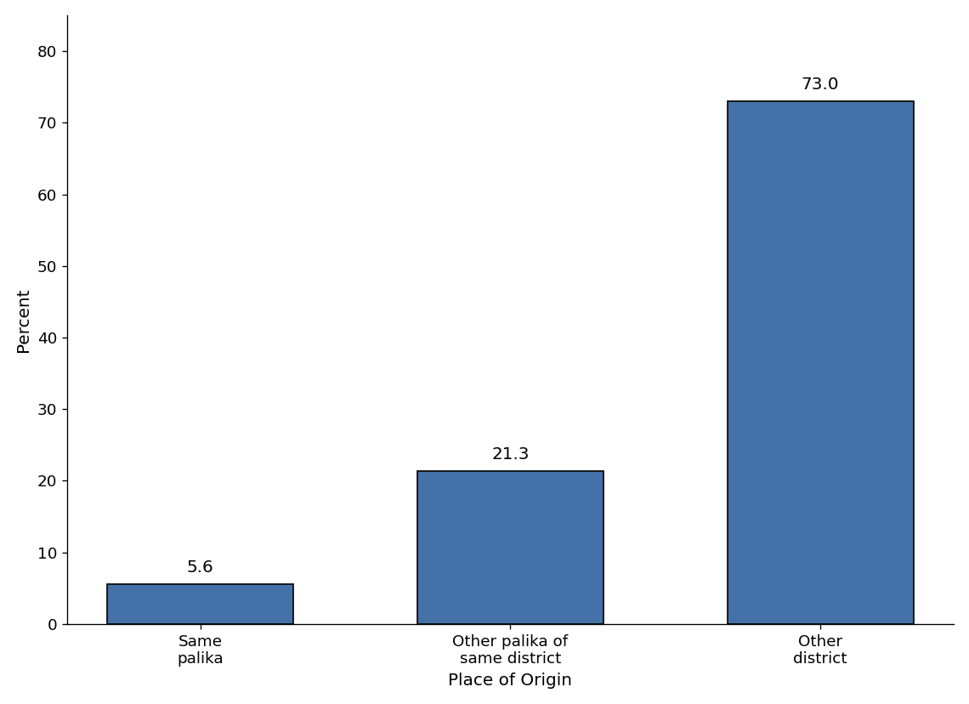
Figure No. 11: Distribution of Migrant Households by Place of Origin

5.1.3 Responsible Person for Decision Making to Migrate
The decision to migrate is rarely made in isolation; it is often shaped or directly taken by another person on behalf of the household, particularly where the migrant is a dependent family member, a spouse, or a child. Identifying who was primarily responsible for the decision to migrate helps to clarify whether migration into the study area is chiefly an individual, family-driven or socially-mediated process. Based on the responses obtained through the questionnaire survey, the distribution of migrant households by the person responsible for making the decision to migrate is presented in the table below.
Table No. 5.1.3: Distribution of Migrant Households by Responsible Person for Decision Making to Migrate
Responsible Person | No. of Households | Percent (%)
Near relatives | 25 | 28.1
Spouse/children | 21 | 23.6
Friends | 15 | 16.9
Himself/Herself | 15 | 16.9
Employers/Neighbors | 13 | 14.6
Total | 89 | 100.0
Source: Field Survey, 2025.
Table No. 5.1.3 shows that near relatives were the single most commonly reported source of the migration decision, accounting for 25 households (28.1%), followed by spouse or children at 23.6 percent. Together, decisions attributed to relatives, spouses or children — that is, decisions made within the wider family circle rather than by the migrant alone — account for more than half (51.7%) of all households, underscoring the strongly family-mediated nature of the migration process in the study area. Friends (16.9%) and the migrants themselves (16.9%) were reported in equal measure, while employers or neighbors were cited by 13 households (14.6%) as the least common source of the decision. This pattern suggests that migration into Shankharapur Ward 9 (Sankhu) is, in most cases, not a purely individual choice but one embedded in existing kinship and social networks, consistent with the finding in Section 5.1.2 that a large majority of migrants came from beyond their own district and were likely to have relied on relatives or family already settled in or familiar with the destination area.
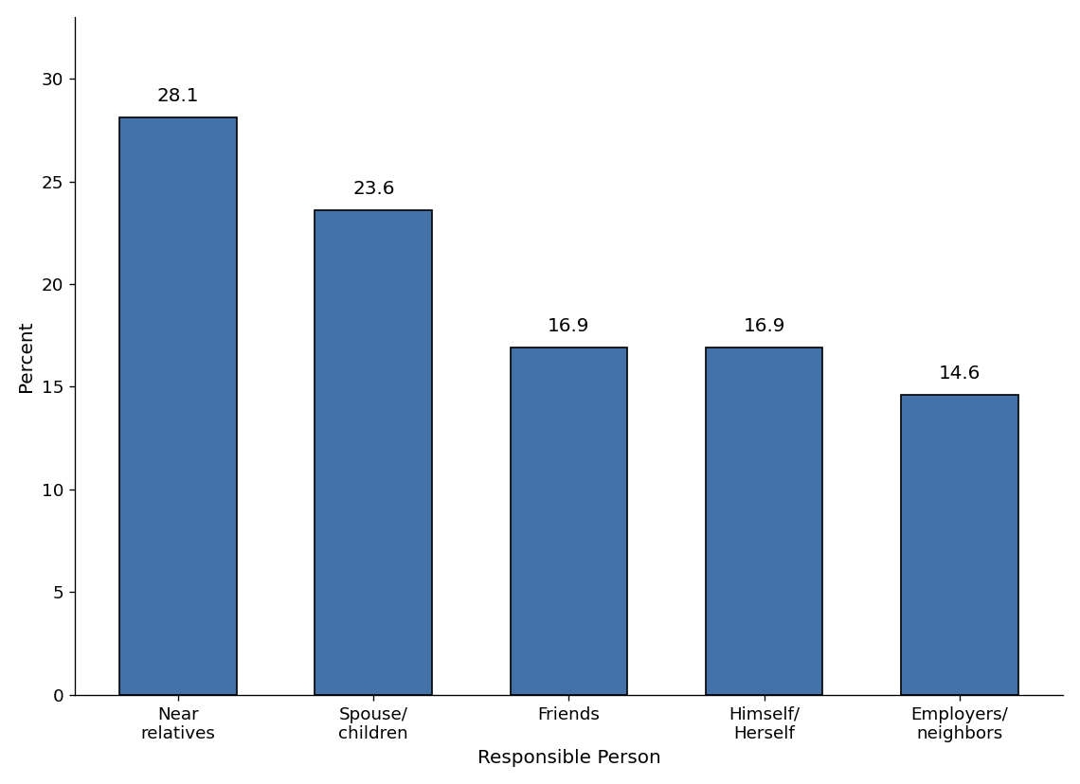
Figure No. 12: Distribution of Migrant Households by Responsible Person for Decision Making to Migrate

5.2 Consequences of Migration
While the previous section examined the causes that led migrant households to leave their place of origin, migration also brings about a range of consequences at the place of destination, both positive and negative. These consequences may be reflected in the migrants' satisfaction with their current place of residence, the problems they continue to face after settling in Shankharapur Ward 9 (Sankhu), their future intention to remain there, and the changes they have experienced in aspects of their lives such as culture, occupation, food habit and access to education. This section examines these consequences in turn, drawing on the responses obtained through the questionnaire survey.

5.2.1 Satisfaction with Current Place of Residence
Satisfaction with the current place of residence is one of the most direct indicators of the overall consequence of migration for a household, as it reflects the migrant's own assessment of whether the move has met their expectations. In this study, respondents were asked whether they were satisfied with their current place of residence, whether they were not satisfied, or whether their situation felt no different from before migration. Based on the responses obtained through the questionnaire survey, the distribution of migrant households by satisfaction with the current place of residence is presented in the table below.
Table No. 5.2.1: Distribution of Migrant Households by Satisfaction with Current Place of Residence
Satisfaction | No. of Households | Percent (%)
Yes | 79 | 88.8
No | 8 | 9.0
Same as before | 2 | 2.2
Total | 89 | 100.0
Source: Field Survey, 2025.
Table No. 5.2.1 shows that the overwhelming majority of migrant households, 79 out of 89 (88.8%), reported that they are satisfied with their current place of residence, indicating that migration has, for most households, met or exceeded the expectations that motivated the move. Only 8 households (9.0%) reported that they are not satisfied, while a further 2 households (2.2%) reported that their situation feels no different from before migration. This high overall level of satisfaction is consistent with the pattern already observed in Section 5.1.1, where limited infrastructure, job opportunity and market access were the leading reasons for leaving the place of origin: for most households, relocating to Shankharapur Ward 9 (Sankhu) appears to have resolved the very constraints that originally drove them to migrate.
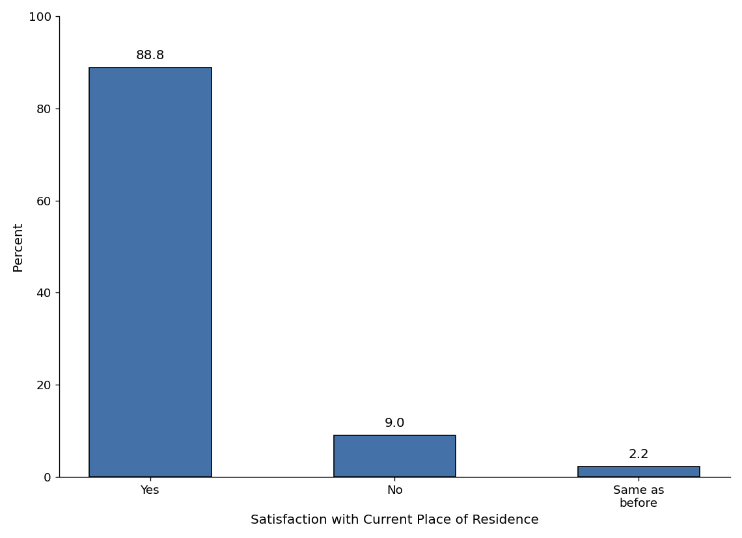
Figure No. 13: Distribution of Migrant Households by Satisfaction with Current Place of Residence

5.2.2 Problems Facing at Destination
Although migration is generally undertaken in search of better opportunities, the place of destination is not always free of difficulties. Identifying the problems that migrant households continue to face after settling in Shankharapur Ward 9 (Sankhu) helps to highlight the gaps that remain in local infrastructure and services despite migration having occurred. In this study, respondents were asked to identify the single most important problem they face at their current place of residence. Based on the responses obtained through the questionnaire survey, the distribution of migrant households by the main problem facing at the current place of residence is presented in the table below.
Table No. 5.2.2: Distribution of Migrant Households by Problems Facing at the Current Place of Residence
Problems | No. of Households | Percent (%)
Inadequate development funding | 35 | 39.3
Insufficient health facilities | 17 | 19.1
Bad social environment | 16 | 18.0
Lack of employment opportunity | 14 | 15.7
Inadequate drinking water supply | 7 | 7.9
Total | 89 | 100.0
Source: Field Survey, 2025.
Table No. 5.2.2 shows that inadequate development funding is the single most commonly reported problem facing migrant households at their current place of residence, cited by 35 households (39.3%) — well ahead of any other single problem. Insufficient health facilities (19.1%) and a bad social environment (18.0%) are the next most frequently reported problems, followed by lack of employment opportunity (15.7%). Inadequate drinking water supply is the least commonly reported problem, cited by only 7 households (7.9%). Taken together, these findings suggest that although migrant households have generally gained better access to physical facilities than at their place of origin (as shown in the causes discussed in Section 5.1.1), local infrastructure and service delivery in Shankharapur Ward 9 (Sankhu) — particularly development funding, health and employment — have not fully kept pace with the sustained inflow of in-migrants, and remain the principal sources of continuing difficulty for migrant households at the destination.
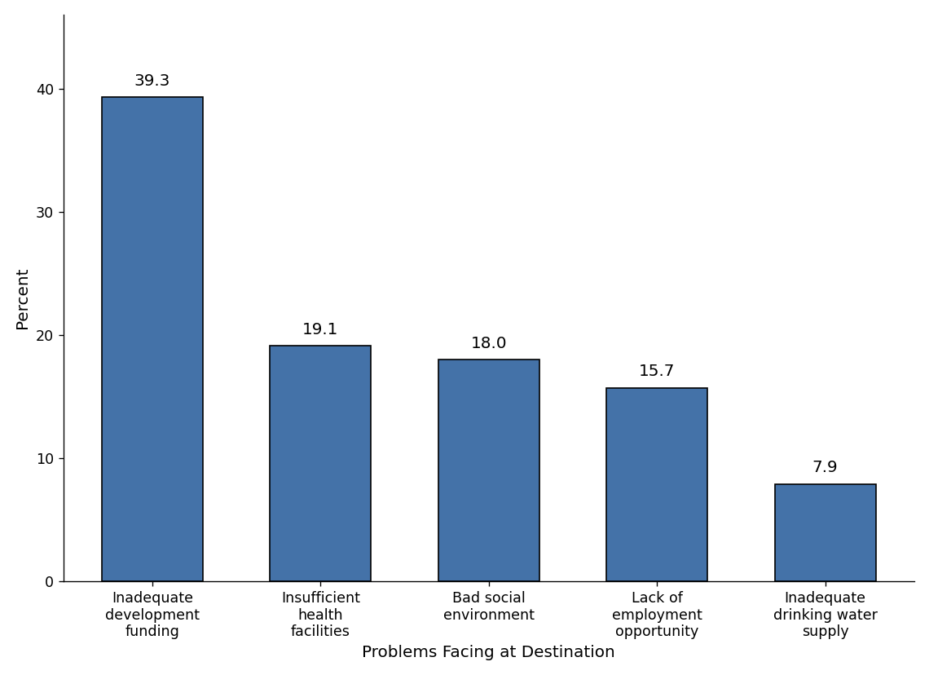
Figure No. 14: Distribution of Migrant Households by Problems Facing at the Current Place of Residence

5.2.3 Permanency of Households in the Study Area
Whether migrant households intend to remain permanently at their current place of residence is an important indicator of the overall success of migration from the migrants' own point of view. A high proportion of households wishing to stay on suggests that migration has largely met their expectations, whereas a notable share wishing to move away again points to unresolved difficulties at the destination. Based on the responses obtained through the questionnaire survey, the distribution of migrant households by their future intention regarding permanent residence is presented in the table below.
Table No. 5.2.3: Distribution of Migrant Households by Future Intention to Live Permanently
Want to Live Permanently | No. of Households | Percent (%)
Yes | 76 | 85.4
No | 13 | 14.6
Total | 89 | 100.0
Source: Field Survey, 2025.
Table No. 5.2.3 shows that a large majority of migrant households, 76 out of 89 (85.4%), intend to live permanently at their current place of residence, while 13 households (14.6%) reported wanting to move to another town or village in the future. This high proportion of households intending to stay on is broadly consistent with the satisfaction levels reported in Section 5.2.1, and suggests that, on balance, migration into Shankharapur Ward 9 (Sankhu) has been a settled and largely successful transition for most migrant households, even though the problems identified in Section 5.2.2 indicate that the destination is not entirely without shortcomings.
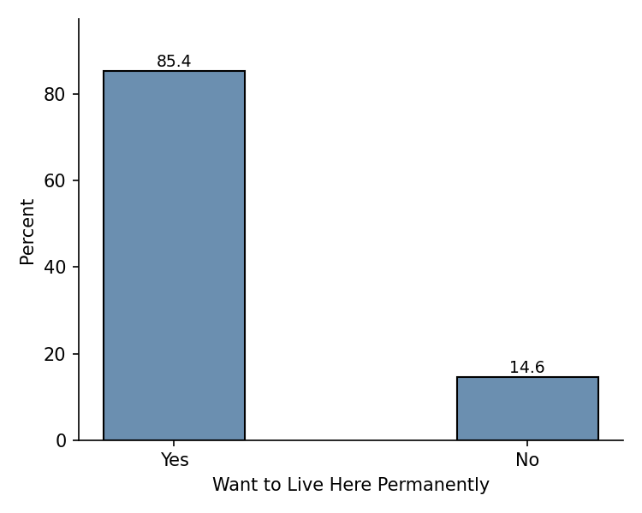
Figure No. 15: Distribution of Migrant Households by Future Intention to Live Permanently

5.2.4 Changes in Some Aspects of Migrants
Migration is not only a change of residence but can also bring about changes in the way migrant households live, work and access services. In this study, respondents were asked whether they had experienced any change, since migrating, in four specific aspects of their lives: culture, occupation, food habit, and access to education. Based on the responses obtained through the questionnaire survey, the distribution of migrant households reporting a change in each of these aspects is presented in the table below.
Table No. 5.2.4: Distribution of Migrant Households by Changes in Selected Aspects
Changed Aspect | Yes No. | Yes % | No No. | No %
Culture | 15 | 16.9 | 74 | 83.1
Occupation | 12 | 13.5 | 77 | 86.5
Food Habit | 8 | 9.0 | 81 | 91.0
Better Education | 71 | 79.8 | 18 | 20.2
Source: Field Survey, 2025.
Table No. 5.2.4 shows a clear contrast between the four aspects examined. Access to education stands out as the aspect most commonly affected by migration, with 71 households (79.8%) reporting a change, indicating that improved access to schooling is among the more tangible benefits migrant households have gained at their current place of residence. By contrast, changes in culture (16.9%), occupation (13.5%) and food habit (9.0%) were reported by a much smaller share of households, suggesting that most migrant households have retained their customary practices, occupation and dietary habits even after relocating. This pattern indicates that while migration into Shankharapur Ward 9 (Sankhu) has meaningfully improved access to education for a large share of households, it has not brought about widespread change in the more deeply rooted aspects of household life such as culture and occupation.
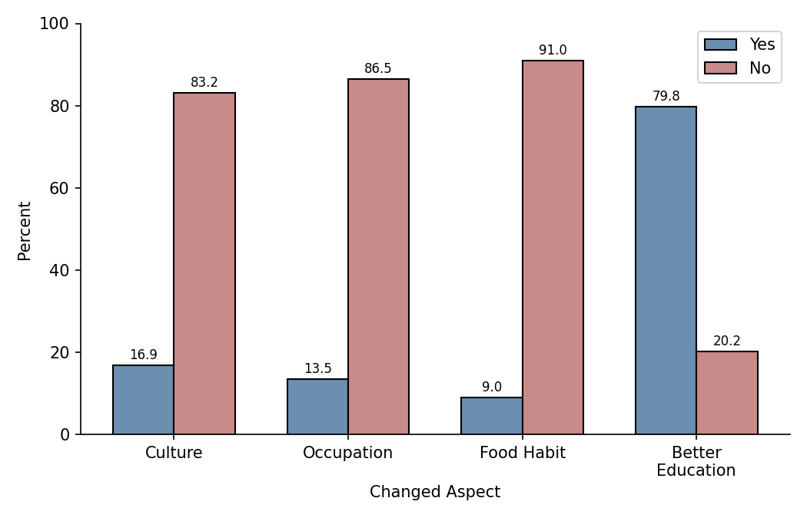
Figure No. 16: Distribution of Migrant Households by Changes in Selected Aspects

6. Comparative Analysis of Main Causes and Consequences of Migration
This chapter presents a comparative analysis of the situation of migrant households before and after migration, drawing together the socio-economic indicators discussed separately in the preceding chapters. Comparing conditions at the place of origin with those at the place of destination provides a more direct basis for assessing the extent to which migration has changed the economic and material circumstances of migrant households, going beyond the causes and consequences examined individually in Chapter Five.

6.1 Income
Monthly household income is one of the most direct indicators of the economic outcome of migration. In this study, respondents were asked to report their average monthly household income both at their place of origin, prior to migration, and at their current place of residence. Based on the responses obtained through the questionnaire survey, the distribution of migrant households by monthly income at the place of origin and the place of destination is presented in the table below.
Table No. 6.1: Distribution of Migrant Households by Monthly Income at Place of Origin and Place of Destination
Monthly Income (Rs.) | Origin No. | Origin % | Destination No. | Destination %
Below 10,000 | 6 | 6.7 | 1 | 1.1
10,000 - 19,999 | 25 | 28.1 | 10 | 11.2
20,000 - 29,999 | 30 | 33.7 | 33 | 37.1
30,000 - 39,999 | 19 | 21.3 | 25 | 28.1
40,000 - 49,999 | 7 | 7.9 | 15 | 16.9
50,000 and above | 2 | 2.2 | 5 | 5.6
Total | 89 | 100.0 | 89 | 100.0
Source: Field Survey, 2025.
Table No. 6.1 shows a clear upward shift in the income distribution of migrant households after migration. At the place of origin, 31 households (34.8%) reported a monthly income below Rs. 20,000, whereas at the place of destination this share fell to 11 households (12.4%). Conversely, the share of households earning Rs. 40,000 or more rose from 9 households (10.1%) at the place of origin to 20 households (22.5%) at the place of destination. The largest single bracket at both places is Rs. 20,000-29,999, but even here the share increased slightly from 33.7 percent to 37.1 percent. Taken together, this pattern indicates that migration into Shankharapur Ward 9 (Sankhu) has, on the whole, been associated with an improvement in the monthly income of migrant households, consistent with the finding in Section 5.1.1 that limited job opportunity and limited market at the place of origin were among the leading reasons for leaving.
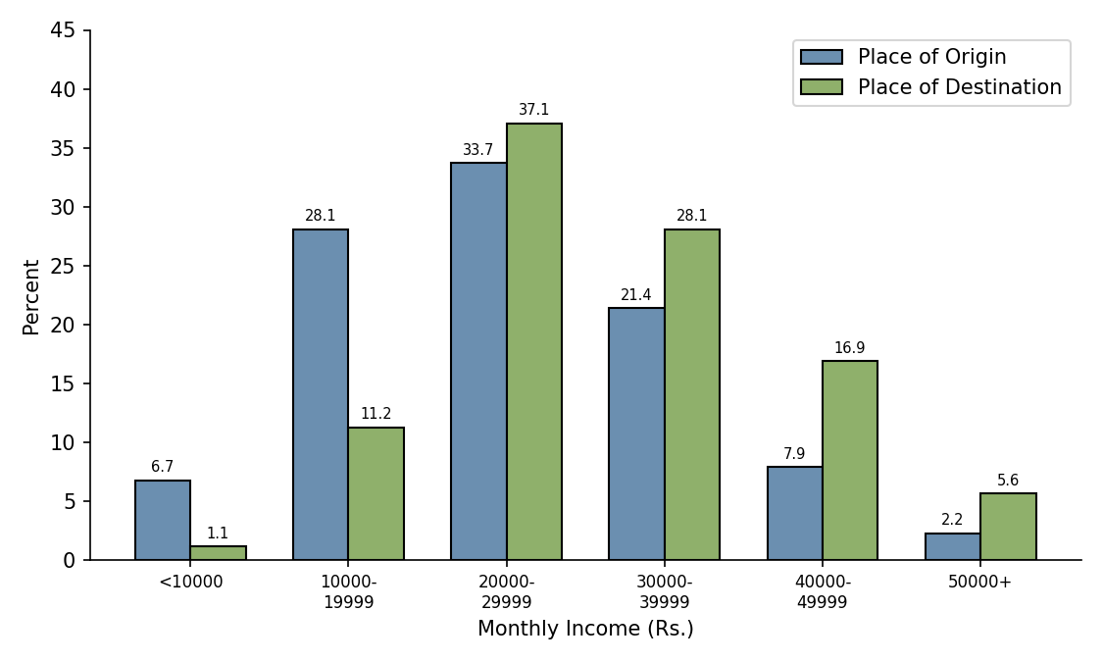
Figure No. 17: Distribution of Migrant Households by Monthly Income at Place of Origin and Place of Destination

6.2 Occupation
Occupation is closely linked to household income and is itself often affected by migration, as households may shift into new lines of work upon settling at a new place of residence. In this study, respondents were asked to report their main occupation both at their place of origin and at their current place of residence. Based on the responses obtained through the questionnaire survey, the distribution of migrant households by occupation at the place of origin and the place of destination is presented in the table below.
Table No. 6.2: Distribution of Migrant Households by Occupation at Place of Origin and Place of Destination
Occupation | Origin No. | Origin % | Destination No. | Destination %
Agriculture | 35 | 39.3 | 32 | 36.0
Business | 21 | 23.6 | 19 | 21.3
Private job | 16 | 18.0 | 17 | 19.1
Other | 7 | 7.9 | 9 | 10.1
Foreign employment | 4 | 4.5 | 4 | 4.5
Government job | 4 | 4.5 | 4 | 4.5
Study/Training | 1 | 1.1 | 3 | 3.4
Not stated | 1 | 1.1 | 1 | 1.1
Total | 89 | 100.0 | 89 | 100.0
Source: Field Survey, 2025.
Table No. 6.2 shows that agriculture remains the single most common occupation of migrant households both before and after migration, although its share has declined somewhat, from 39.3 percent at the place of origin to 36.0 percent at the place of destination. Business shows a similar modest decline, from 23.6 percent to 21.3 percent. In contrast, private job, other occupations, and study/training all show a rise in share, with study/training more than tripling in proportion, from 1.1 percent to 3.4 percent, though this still represents a small absolute number of households. Foreign employment and government job remain unchanged at 4.5 percent each. Overall, the occupational structure of migrant households has shifted only modestly, with a gradual movement away from agriculture toward private-sector employment and other diversified occupations, rather than a wholesale change in livelihood. This is broadly consistent with the income gains observed in Section 6.1, which appear to stem more from a shift within occupational categories than from large-scale occupational transformation.
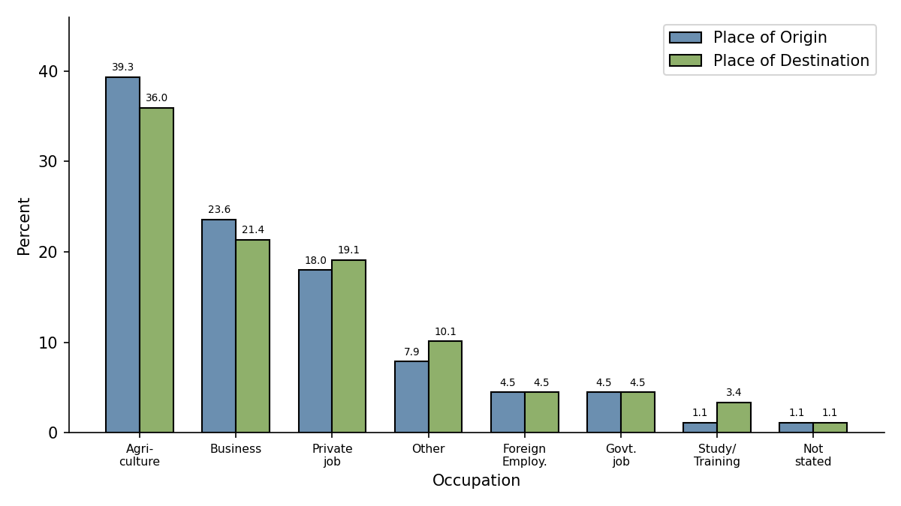
Figure No. 18: Distribution of Migrant Households by Occupation at Place of Origin and Place of Destination

6.3 Physical Facilities
Access to physical facilities such as transport, electricity, communication, schooling and health services is a key determinant of the quality of life of a household, and disparities in such access between the place of origin and the place of destination often act as an important pull factor for migration. In this study, respondents were asked to report whether each of these five facilities was available (or was limited/not available) to them both at their place of origin and at their current place of residence. Based on the responses obtained through the questionnaire survey, the comparison is presented in the table below.
Table No. 6.3: Percentage of Migrant Households Reporting Access to Physical Facilities at Place of Origin and Place of Destination
Physical Facility | Origin: Available (%) | Origin: Limited (%) | Destination: Available (%)
Transport | 67.4 | 32.6 | 100.0
Electricity | 100.0 | 0.0 | 100.0
Communication | 92.1 | 7.9 | 100.0
School | 100.0 | 0.0 | 100.0
Hospital | 38.2 | 61.8 | 100.0
Source: Field Survey, 2025.
Table No. 6.3 shows that access to physical facilities was uneven at the place of origin. Hospital facilities showed the largest gap, with only 38.2 percent of households reporting availability at origin and 61.8 percent reporting it as limited, followed by transport, available to 67.4 percent of households at origin. Electricity and school, by contrast, were already available to all or nearly all households at the place of origin (100.0% and 100.0% respectively), while communication was available to 92.1 percent. At the place of destination, all five facilities were reported as available by 100 percent of households. Given that every facility converges to exactly 100 percent at the destination, this finding should be read with some caution: it may reflect a genuine, near-universal level of physical infrastructure in Shankharapur Ward 9 (Sankhu) given its proximity to urban services, but a uniform 100 percent across all categories could also indicate that the destination-side question was interpreted by respondents as a simple presence/absence check rather than a measure of adequacy, and does not capture possible differences in the quality, reliability or cost of these facilities at the destination. With that caveat noted, the gap between origin and destination is clearly widest for hospital and transport facilities, indicating that improved access to health services and transportation are likely to be among the more significant welfare gains associated with migration into the study area.
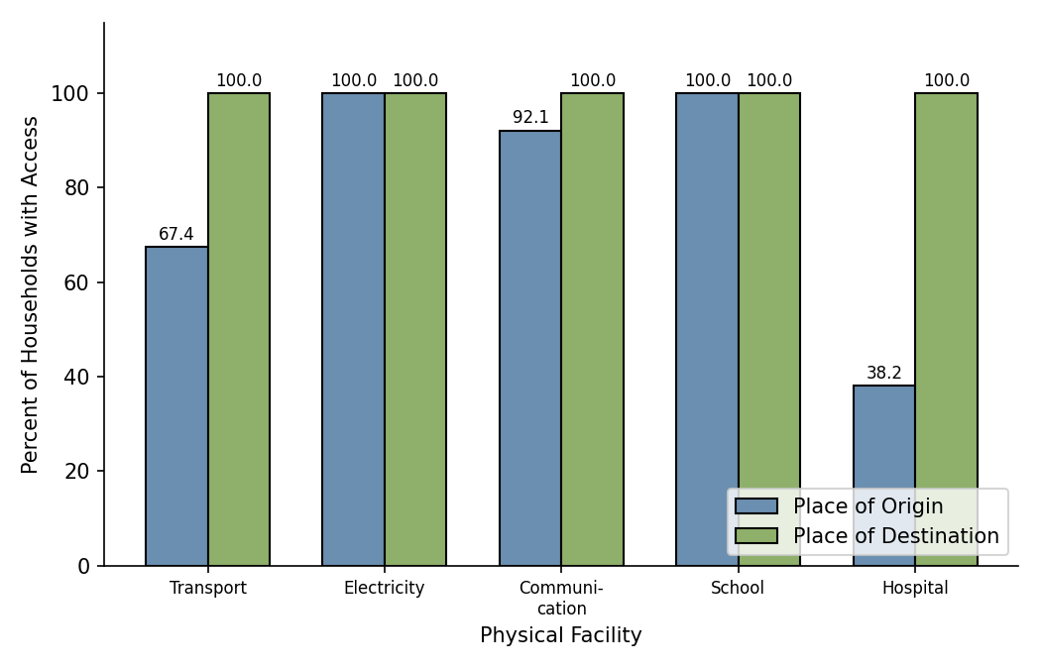
Figure No. 19: Percentage of Migrant Households Reporting Access to Physical Facilities at Place of Origin and Place of Destination

6.4 Suggestion to the Relatives
After settling at the place of destination, migrants form their own impression of whether the move was worthwhile, and this impression often shapes the advice they give to relatives and friends who are still at the place of origin. Such suggestions can, in turn, influence the future flow of migration into the study area. Respondents were therefore asked what they would suggest to their relatives regarding coming to Shankharapur Ward 9 (Sankhu). The responses are presented below.
Table No. 6.4: Distribution of Migrant Households by Suggestion Given to Relatives
Suggestion to Relatives | No. of Respondents | Percent
Come here | 64 | 71.9
As you like | 20 | 22.5
Go to another place | 5 | 5.6
Total | 89 | 100.0
Source: Field Survey, 2025.
Table No. 6.4 shows that a large majority of respondents, 64 (71.9%), would suggest that their relatives come to this place, indicating a generally positive assessment of the migration experience among the surveyed households. A further 20 respondents (22.5%) said it was up to the relatives themselves to decide (“as you like”), reflecting a neutral stance rather than active discouragement. Only 5 respondents (5.6%) suggested that relatives go to another place instead. Taken together, more than nine in ten respondents (94.4%) gave either a positive or a neutral response, and only a small minority actively discouraged further migration to the study area, which is broadly consistent with the high level of satisfaction with the current place of residence reported in Section 5.2.1.
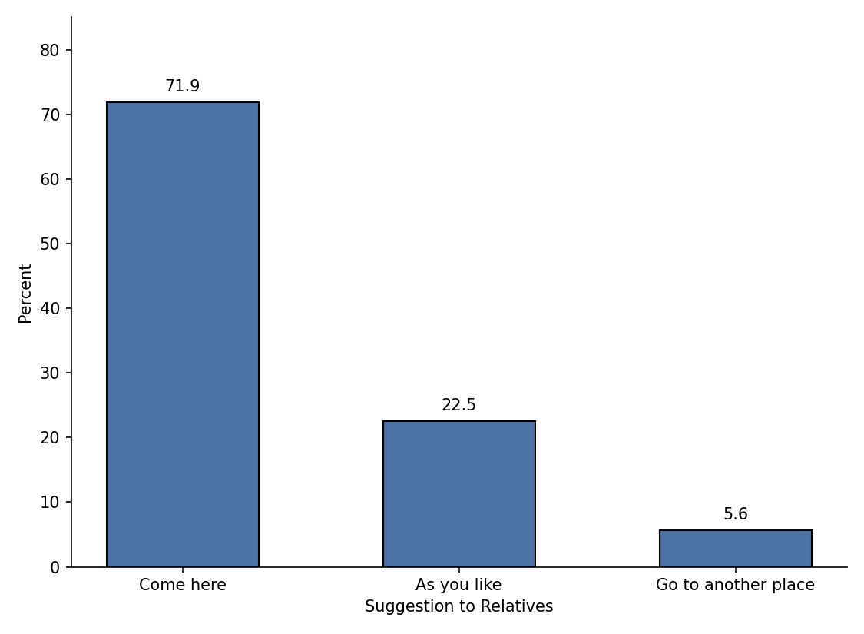
Figure No. 20: Distribution of Migrant Households by Suggestion Given to Relatives

6.5 Impact of Migration in Shankharapur Ward 9 (Sankhu)
The preceding sections have examined the causes, consequences and comparative socio-economic position of migrant households individually. This section draws these threads together to summarize the overall impact of in-migration on Shankharapur Ward 9 (Sankhu), considered under two broad heads: the demographic impact, and the socio-economic impact on migrant households and the destination community.
A. Demographic Impact of In-Migration
Population Growth: The direct demographic effect of in-migration is the addition of 345 persons across 89 households (Table No. 4.2.1) to the population of Shankharapur Ward 9 (Sankhu). Since 73.0 percent of these households moved in from a different district altogether (Table No. 5.1.2), this addition represents a genuine net inflow into the ward rather than a redistribution of population already within the same local area. Because the migrant population is concentrated in the economically active age groups and carries a comparatively low overall dependency ratio of 25.0 (Table No. 4.2.4), the population added by in-migration is weighted toward working-age individuals rather than a large dependent burden. The cross-sectional design of this study does not allow the indirect demographic effects of in-migration, that is, births and deaths occurring among migrant households after their arrival, to be measured directly; the comparatively small children's population recorded in the 0-9 age group (21 persons, Table No. 4.2.1) is consistent with some such natural increase having taken place since settlement, though this cannot be confirmed from the data collected.
Compositional Impact: In-migration has also altered the social composition of the ward relative to the national population. Ethnically, Chhetri (36.0%) and Brahmin (31.5%) households together account for more than two-thirds of migrant households (Table No. 4.1.2), while religiously, Buddhist households are markedly over-represented among migrants (25.8%) relative to their national share (8.21%, NSO, 2021), and Hindu households, while still the majority, fall short of their national share (67.4% against 81.19% nationally) (Table No. 4.1.3). In-migration has therefore contributed to a social composition in the ward that differs in some respects from the national pattern.
B. Socio-Economic Impact of In-Migration
Social Impact: The decision to migrate was, in most cases, family-mediated rather than purely individual: decisions attributed to near relatives, spouses or children together account for more than half of all households (51.7%, Table No. 5.1.3), suggesting that migration has generally reinforced rather than weakened kinship networks between the place of origin and the place of destination. Among the aspects of life most visibly affected by migration, access to education stands out, with 79.8 percent of households reporting improvement (Table No. 5.2.4), indicating a tangible social benefit for migrant families. By contrast, comparatively few households reported a change in culture (16.9%), suggesting that migrant households have largely retained their customary practices and identity rather than assimilating wholesale into a new social environment. At the same time, a bad social environment was reported as the main difficulty by 18.0 percent of households (Table No. 5.2.2), indicating that social friction at the destination remains a live concern for a meaningful minority.
Economic Impact: Migration is associated with a clear improvement in household income: the share of households earning below Rs. 20,000 per month fell from 34.8 percent at the place of origin to 12.4 percent at the place of destination, while the share earning Rs. 40,000 or more rose from 10.1 percent to 22.5 percent (Table No. 6.1). This economic gain, however, has been achieved mainly through improved returns within existing lines of work rather than wholesale occupational change: agriculture remains the single most common occupation both before and after migration, declining only modestly from 39.3 percent to 36.0 percent (Table No. 6.2). Land ownership is near-universal among migrant households at the destination (Table No. 4.1.4), which, together with the reported universal access to physical facilities such as transport, electricity, communication, schooling and health services (Table No. 6.3, read with the caveat noted in that section), points toward a generally improved asset and infrastructure base for migrant households after settlement.
Quality of Life: Taken together, these demographic, social and economic effects are reflected in migrant households' own assessment of their move. A large majority report being satisfied with their current place of residence (88.8%, Table No. 5.2.1), intend to live there permanently (85.4%, Table No. 5.2.3), and would suggest that relatives come to the same place or leave the decision to them (94.4% combined, Table No. 6.4). These positive assessments should nonetheless be read alongside the problems that a meaningful share of households continue to report at the destination, particularly inadequate development funding (39.3%), insufficient health facilities (19.1%) and lack of employment opportunity (15.7%) (Table No. 5.2.2), which indicate that local infrastructure and service delivery in Shankharapur Ward 9 (Sankhu) have not fully kept pace with the scale of in-migration into the ward.
On the whole, in-migration into Shankharapur Ward 9 (Sankhu) appears to have had a predominantly positive impact on migrant households in demographic, social and economic terms, while at the same time placing continuing pressure on local infrastructure and services that has not fully kept pace with the volume of inflow.

7. Summary, Conclusion and Recommendation

7.1 Summary
This study has examined the trends, causes and consequences of in-migration in Shankharapur Ward 9 (Sankhu), Kathmandu, based on a complete enumeration of 89 migrant households comprising 345 persons. The main findings are summarized below.
In terms of socio-economic characteristics, the migrant population is predominantly literate (80.9%), though a marked gender gap remains, with literacy among females (66.9%) considerably lower than among males (93.7%). Migrant households are drawn primarily from the Chhetri (36.0%) and Brahmin (31.5%) ethnic groups, and are predominantly Hindu (67.4%), with a Buddhist share (25.8%) notably higher than the national average. Nearly all migrant households (69.7%) hold relatively small land parcels measured in Aana, and all 89 households reported owning some land, consistent with the municipality's requirement of land ownership for migrant status. Piped water is the leading source of drinking water (53.9%), supplemented by boring (39.3%).
Demographically, the migrant population is fairly balanced by sex (181 males, 164 females; a sex ratio of approximately 110 males per 100 females) and is concentrated in the economically active age groups, with an overall age dependency ratio of only 25.0. Among migrants aged 10 years and above, 62.0 percent are currently married. The average family size of migrant households is 3.88 persons, smaller than both the national average of 4.37 (NSO, 2021) and closely matching the Bagmati Province average of 3.89.
Regarding the causes of migration, limited infrastructure (34.8%), limited job opportunity (27.0%) and limited market access (20.2%) at the place of origin were the leading reasons households reported for leaving, together accounting for more than four-fifths of all households. The large majority of migrant households (73.0%) moved from a different district altogether, and migration decisions were, in more than half of cases (51.7%), made or influenced by near relatives, spouses or children rather than by the migrant alone.
Regarding the consequences of migration, satisfaction with the current place of residence is high (88.8%), and a large majority of households (85.4%) intend to live there permanently. Access to education is the aspect of life most commonly reported as improved after migration (79.8%), while changes in culture, occupation and food habit were reported by comparatively few households, indicating that migrants have largely retained their customary practices. At the same time, inadequate development funding (39.3%), insufficient health facilities (19.1%) and a bad social environment (18.0%) remain the most commonly reported problems at the destination.
The comparative analysis of conditions before and after migration shows a clear improvement in household income, with the share of households earning below Rs. 20,000 per month falling from 34.8 percent at the place of origin to 12.4 percent at the destination, and the share earning Rs. 40,000 or more rising from 10.1 percent to 22.5 percent. This income gain has occurred alongside only a modest shift in occupational structure, with agriculture remaining the single most common occupation both before (39.3%) and after (36.0%) migration. A large majority of respondents (71.9%) would suggest that their relatives come to Shankharapur Ward 9 (Sankhu), and a further 22.5 percent would leave the decision to them, together indicating a broadly positive assessment of the migration experience.

7.2 Conclusion
The findings of this study indicate that in-migration into Shankharapur Ward 9 (Sankhu) is driven predominantly by economic and infrastructural push factors at the place of origin, particularly limited infrastructure, limited job opportunity and limited market access, rather than by social, political or conflict-related causes. The predominance of inter-district migration, together with the strongly family-mediated nature of the migration decision, suggests that kinship networks play an important role in directing the flow of migration toward this study area.
The consequences of migration, on balance, appear favourable for migrant households: incomes have risen markedly after migration, satisfaction with the current place of residence is high, and the large majority of migrant households intend to remain permanently and would recommend the area to relatives. The demographic profile of the migrant population, concentrated in the working-age groups with a comparatively low dependency ratio, is consistent with migration driven primarily by livelihood motives rather than by dependents accompanying working members.
At the same time, this generally positive picture should be read alongside the problems that a meaningful share of migrant households continue to report at the destination, particularly inadequate development funding, insufficient health facilities and lack of employment opportunity. These findings suggest that while migration has, on the whole, improved the economic circumstances of migrant households, local infrastructure and service delivery in Shankharapur Ward 9 (Sankhu) have not fully kept pace with the sustained inflow of migrants, and continued in-migration is likely to place further pressure on these services unless addressed.

7.3 Recommendation
On the basis of the findings of this study, the following recommendations are made for the concerned local authorities and stakeholders:
- Development funding and basic infrastructure in Shankharapur Ward 9 (Sankhu) should be strengthened, as inadequate development funding was the single most commonly reported problem among migrant households (39.3%) and is likely to become more pressing as in-migration continues.
- Health facilities at the destination should be improved and expanded, given that insufficient health facilities were the second most commonly reported problem (19.1%) despite health infrastructure already being comparatively better at the destination than at the place of origin.
- Local employment opportunities should be expanded, since lack of employment opportunity remains a reported problem for a meaningful share of households (15.7%) even after migration, and limited job opportunity was itself among the leading reasons households left their place of origin.
- The municipality should formally confirm and document the exact year and terms of the land-ownership requirement for migrant status referenced in Section 4.1.4 of this study, so that the administrative basis for this requirement is clearly recorded for future reference and research.
- Since female literacy (66.9%) remains substantially lower than male literacy (93.7%) among the migrant population, targeted adult literacy and education programmes for women should be considered.
- Future studies on migration into this study area should collect household-level data capable of supporting cross-tabulations, such as ethnicity by occupational mobility, which the present study, based on aggregate tables, was not able to construct.

Remaining To-Do List (Author Notes — not part of the chapter text)
The following items remain outstanding and require action before this chapter (and related cross-references in other chapters) can be finalized.
1. Ethnicity × Occupation cross-tab (needs raw household-level data) — required for the Table 6.2 occupational-mobility link discussed in the Ethnicity section.
2. Add NSO 2021 citation to the References list (References chapter is not part of this working file — paste this entry in alphabetically by first author surname: National Statistics Office (NSO). (2021). National Population and Housing Census 2021: National Report. Kathmandu: National Statistics Office, Government of Nepal. Also add the in-text citation style "(NSO, 2021)" used in Section 4.2.3.).
3. Review Chapter 3 methodology wording — "sample" vs. "census / complete enumeration": the 89 households represent the full count of migrant households in Shankharapur Ward 9 (Sankhu), not a probability sample.
4. Confirm the exact year (2076 B.S.?) of the land-ownership rule change with the municipality, referenced in Section 4.1.4.
Resolved: The apparent discrepancy between the marital status total (324) and the migrant population total (345) has been verified and explained in Section 4.2.2 — the marital status question was administered only to migrants aged 10 years and above.
Resolved: The data conflict in the "Satisfaction" sheet of tables.xlsx has been confirmed as N=89 throughout the study (Yes=79/88.8%, No=8/9.0%, Same as before=2/2.2%). Section 5.2.1 (Satisfaction with Current Place of Residence) has been written using these figures, and the former Section 5.2.1 (Problems Facing at Destination) has been renumbered to 5.2.2, with Figure No. 13 (Satisfaction) inserted ahead of the renumbered Figure No. 14 (Problems Facing at Destination).

